Technology Bucket – Security & Surveillance

Category – Software

Problem statement – License Plate Recognition - CB31

Organization – MIXORG

Team Name – Team Tesseract

Team Leader name – RK Rahul

**Problem Statement**

Many residential society administrations, tolls, business complexes and parking spaces in India lack an automated system for car parking and vehicle monitoring. Most of the commercial and residential places face an impending problem of illegal car/vehicle parking inside their premises. This issue is not bounded to just parking, but also adds to the security concerns inside those establishments. Though there are solutions that exist in the market, the affordability comes into question. In this regard, we would like to have an affordable solution that caters to the Indian markets Expectation: For the team choosing this topic, we expect to have a working model / infrastructure of the solution wherein, when a vehicle passes through a check post and the solution identifies as many features as it can regarding the situation of the vehicle. All Teams will be provided with an amount of video footage. The teams must build a fictitious database based on the vehicles appearing in footage and demonstrate the problems that they are able to solve/automate in existing infrastructure. Applicants will be provided video data through the following website link. http://mixorg.com/competitions/SIH-2020/registration. Each team is supposed to download the data and annotate it according to the features they are going to build. Teams must come up with new features for monetization of their business model and must build machine learning models (for preliminary shortlisting and finals) and required mobile/web applications (for finals only) reflecting the same features. Teams are requested to share the annotations done by them on the video data and the pattern of annotation. Teams are requested to build the machine learning model and share a working code on GitHub. Teams will be judged on the following grounds in the same order as written for the next round: 1. Accuracy of the model in performing the expected task. 2. Speed of the model in performing the expected task. 3. The precision followed during annotation of data. 4. The relevance of annotations considering the problem the team is expecting to solve with it.

**Solution/Innovation**

This objective of the project is to develop a License Plate Recognition system that can identify the license plates in real time and monitor different vehicles of a particular area from the live video feed from the security camera using various image processing and machine learning techniques. A database is created with details such as images of resident's vehicles, owner information, type of vehicle and their license plate details which will be used during the verification phase. A machine learning model is trained using vehicles dataset in order to detect and recognize vehicles such as cars, bikes, etc. entering and leaving the residential area. The images from the live video feed are processed frame by frame using vehicle detection model. Once a vehicle is detected, the background is eliminated by applying image processing techniques such as edge detection and binarization to the region of interest. The region containing the license plate is cropped and fed into an Optical Character Recognition tool - pytesseract to recognize the text in the number plate. The image of the vehicle and the recognized license plate number is compared with the details stored in the Database. The vehicle can be concluded as one of the residents if it matches with the database. Otherwise, the vehicle is considered to be a visitor vehicle and will be updated in a separate database for visitors. This will help in continuous and autonomous monitoring of vehicles in various places such as residence, offices, malls, theatres, parking lots and other public places.

**Solution Steps**

1. Create a Database containing images of vehicles of residence including their license plate number.
2. Train a machine learning module to detect and recognize vehicles.
3. Process the live video feed frame by frame from security cameras and apply image processing techniques such as Edge Detection and Binarization.
4. Remove background noise and crop only the area with the license plate.
5. Apply Optical Character Recognition to recognize the text in the number plate.
6. 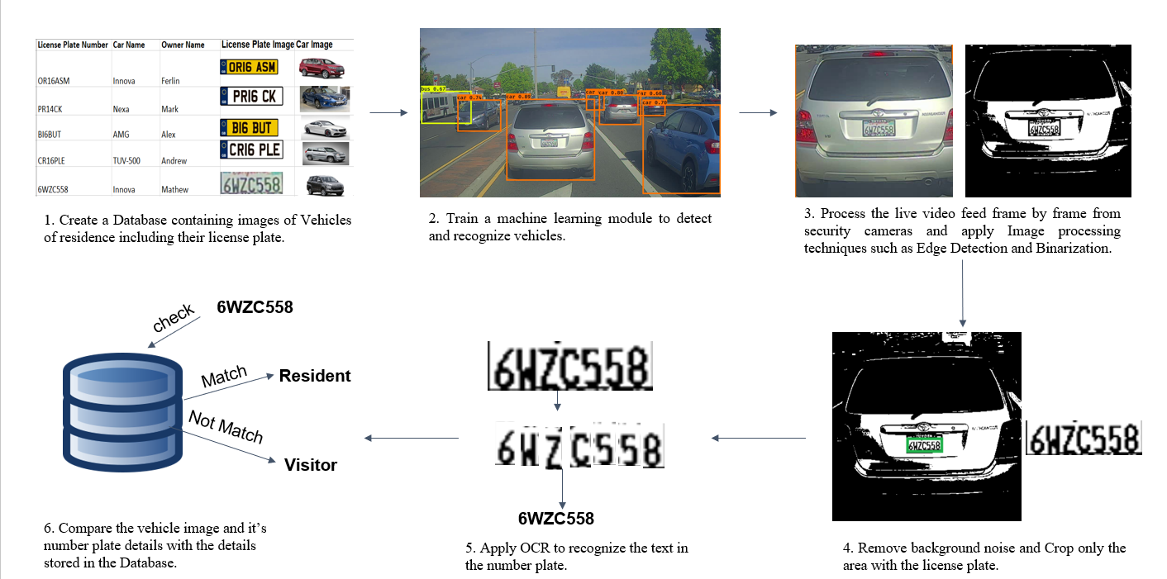Compare the Vehicles image and its number plate details with the details stored in the database.

**Value Proposition**

1. LPR is a real-time monitoring Autonomous system.
2. Processes multiple license plates quickly and accurately in less time.
3. Works even with misaligned letters in the license plate.
4. Pytesseract is a powerful tool that will help to extract the text in the license plate.

**Differentiation**

1. The LPR system will work in different types of environmental conditions.
2. It provides tracking features.
3. Helpful for security and surveillance.
4. Fast and accurate.
5. Provides additional information about the vehicles.

**Core Technology**

* **Python –** The project is implemented using Python programming language.
* **OpenCV –** It is an image processing library in C++, Python.
* **Tesseract –** It is an open-source OCR engine that can recognize and extract text from images.
* **PyOcr –** It is another OCR tool wrapper for python.
* **NumPy –** It is the fundamental package for scientific computing with Python**.**
* **Keras –** It is a high-level neural networks API, written in Python and capable of running on top of TensorFlow, CNTK or Theano. It supports convolutional neural networks.
* **Matplotlib –** It is a dependency used for plotting graphs and displaying images.
* **LabelImg -** It is a graphical image annotation tool and label object bounding boxes in images.
* **Darkflow –** It is a type of YOLO (You Only Look Once) implementation and it can able to detect objects in images and videos. It translates Darknet to TensorFlow. Load trained weights, retrain or fine-tune using TensorFlow, export constant graph definitions to mobile devices.
* **Darknet –** It is an open-source neural network framework written in C and CUDA. It supports CPU and GPU computation.
* **TensorFlow** – It is a free and open-source software library for dataflow programming across a range of tasks. It is a symbolic math library and also used for machine learning applications such as neural networks.

**Team Details**

|  |  |  |  |  |
| --- | --- | --- | --- | --- |
|  | **Name** | **Gender** | **Email id** | **Mobile number** |
| Team leader | Rahul RK | Male | rahulrk.2303@gmail.com | 8778109200 |
| Team member | Shantha Kumar | Male | shantha2106@gmail.com | 9080853461 |
| Team member | Sairamnath K | Male | ksairamnath@gmail.com | 8939551460 |
| Team member | Mohammed Thowfiq S | Male | mohammedthowfiq2@gmail.com | 7010744945 |
| Team member | Vykunth Rao | Male | stingrose@gmail.com | 8939030712 |
| Team member | Navya Reddy V M | Female | venati.navya@gmail.com | 9600076246 |

**Team Skillset**

* **RK Rahul**
  + Quick learner, Adaptive, Motivated, Leadership and Decision making
  + **Projects & Prizes :**
    - Digitization of tabular data from scanned documents
    - Analysis of performance on Online Quizzes using Image processing and Machine learning
    - Paper presentation on Licence Plate Recognition
    - Assistive tool for visually challenged people
    - American Sign Language Recognition
    - Self-driving car simulation using Artificial Intelligence and Convolutional Neural Networks
    - Automatic extraction of Pan-card and License details from scanned documents
    - Secured 2nd place in Ethical hacking hackathon conducted by HackUp technology.
  + **Technical Skills :**
    - Image processing
    - Machine learning & Deep learning algorithms
* **Shantha Kumar**
  + Problem solving, Flexibility, Hardworking, Presentation skills
  + **Projects & Prizes :**
    - Real-time Vehicle Detection and Tracking using Machine Learning and HOG algorithm.
    - Undergraduate research assistant at solarillion foundation machine learning team.
    - Analysing of cinema data using machine learning and shell scripts.
    - Website development and maintenance for Forese club.
  + **Technical Skills** **:**
    - Machine Learning
    - Image processing
* **Sairamnath K**
  + Critical and Creative thinking, Analytical skills, Management skills
  + **Projects & Prizes :**
    - Real-time Vehicle Detection and Tracking using Machine Learning and HOG algorithm.
    - Secured 2nd place in Ethical hacking hackathon conducted by HackUp technology.
  + **Technical Skills :**
    - Data analytics and Data science
    - Image processing
* **Mohammed Thowfiq S**
  + Innovative, Time management, Commitment and Self-management
  + **Projects & Prizes :** 
    - Secured 1st place in Ethical Hacking hackathon conducted by HackUp Technology.
    - Face Detection and Recognition for Security and Surveillance Systems using Artificial Intelligence and Computer Vision.
    - Object Detection and Classification using Deep Learning.
    - Fake News Analysis using Natural Language Processing.
    - Developed an android app for online shopping.
    - Developed an android app for booking parking spots.
  + **Technical Skills :**
    - Machine Learning and Deep Learning algorithms
    - App development
    - Database management
* **Vykunth Rao**
  + Teamwork and Collaboration, Logical Reasoning and Determined
  + **Projects & Prizes :**
    - Movie recommendation engine using Artificial Intelligence.
    - Website for D.G Vaishnav college using HTML / CSS / Javascript / MySQL
    - Paper presentation on Licence Plate Recognition
    - Secured 2nd place in Ethical hacking hackathon conducted by HackUp technology.
    - Undergraduate Research assistant at Solarillion foundation's machine learning stream
  + **Technical Skills :**
    - Machine learning
    - Web development
* **Navya Reddy V M**
  + Communication skills, Professionalism, Reliable and Dependable
  + **Projects & Prizes :**
    - Voice Assistant using Artificial Intelligence and Natural Language Processing.
    - Audio book for visually challenged
  + **Technical Skills :**
    - Machine learning
    - Software development
    - Documentation and Modelling